**Indian Institute of Technology Bombay**

**Department of Aerospace Engineering**

**AE706 – Computational Fluid Dynamics**

Assignment 5 Report

Report By:

Mayank Bajaj

Roll No.- 210010039

Course Instructor: Prof. J. C. Mandal

April 25, 2024

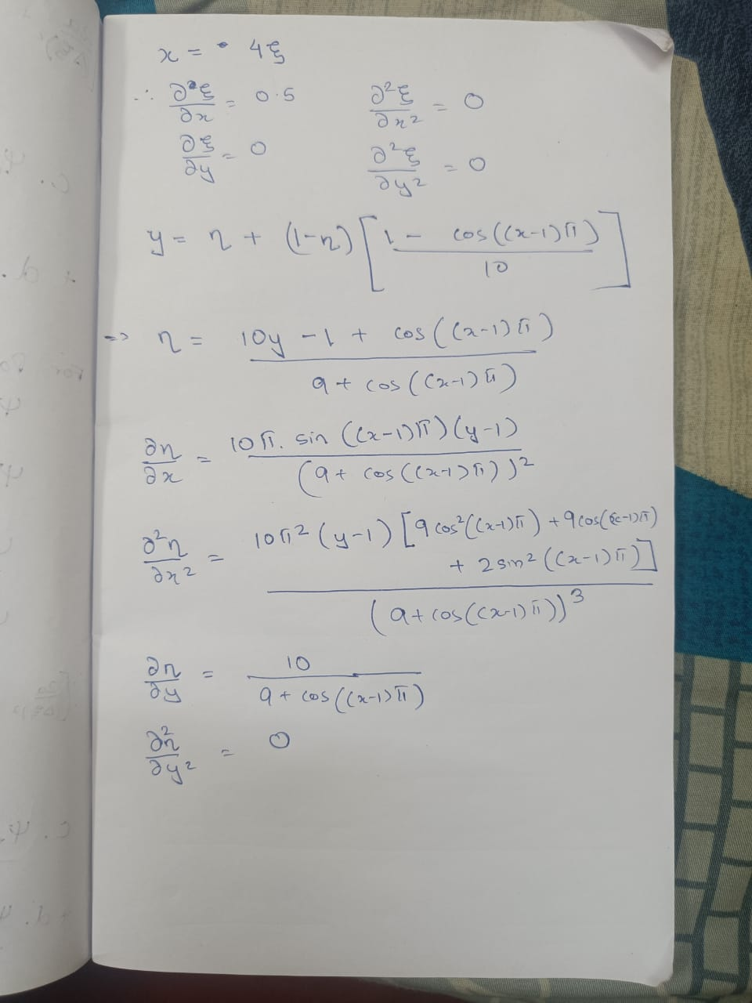Transformation Derivatives:

Laplace equation:

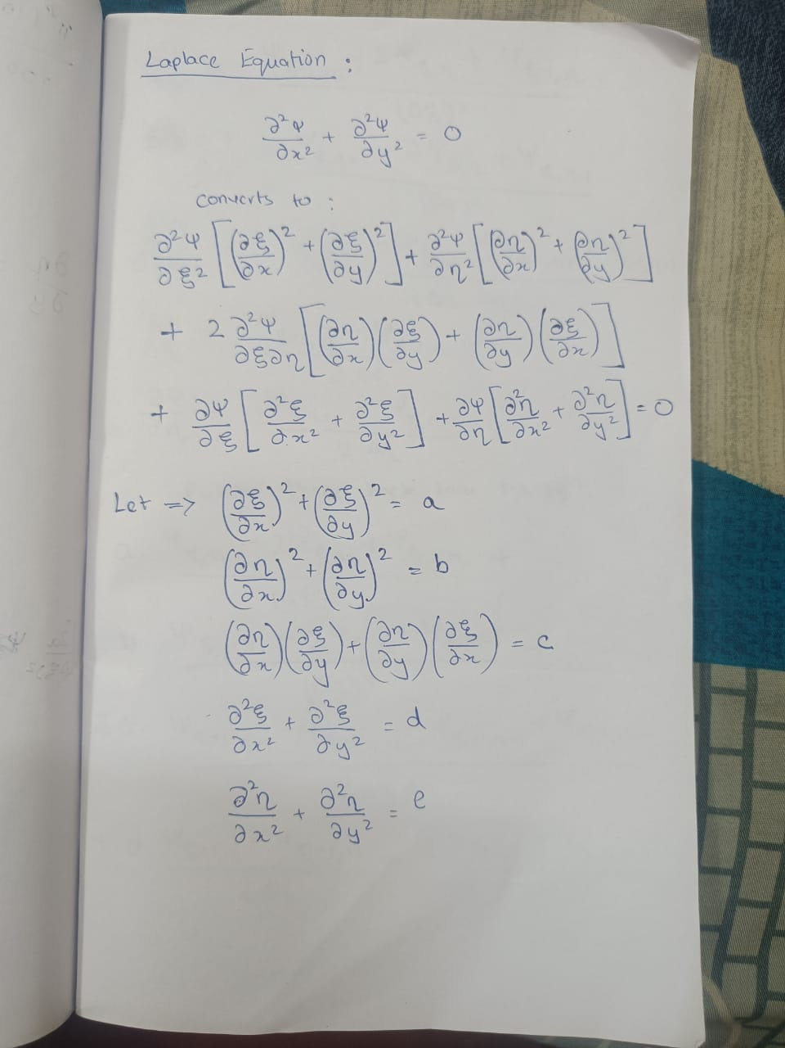

Finite Difference Equation:

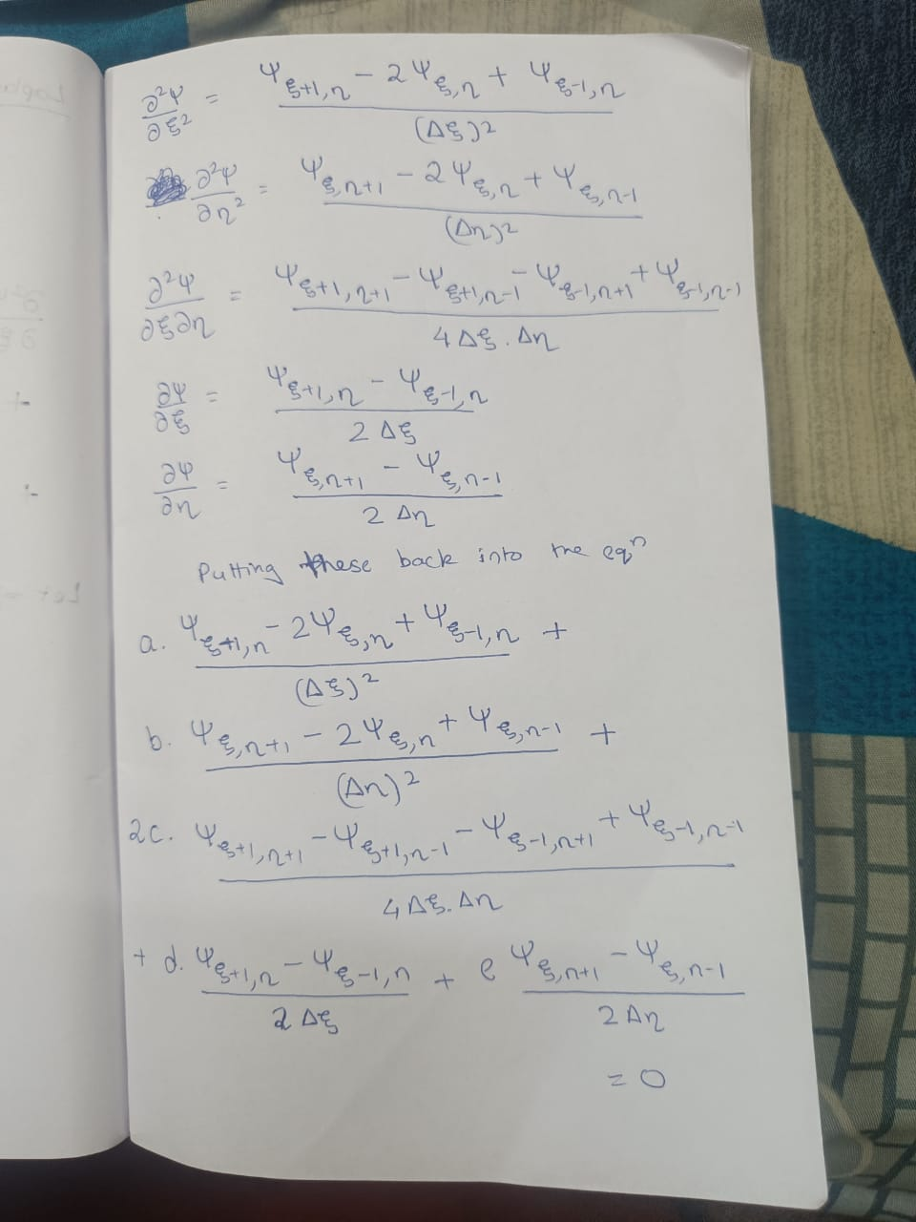

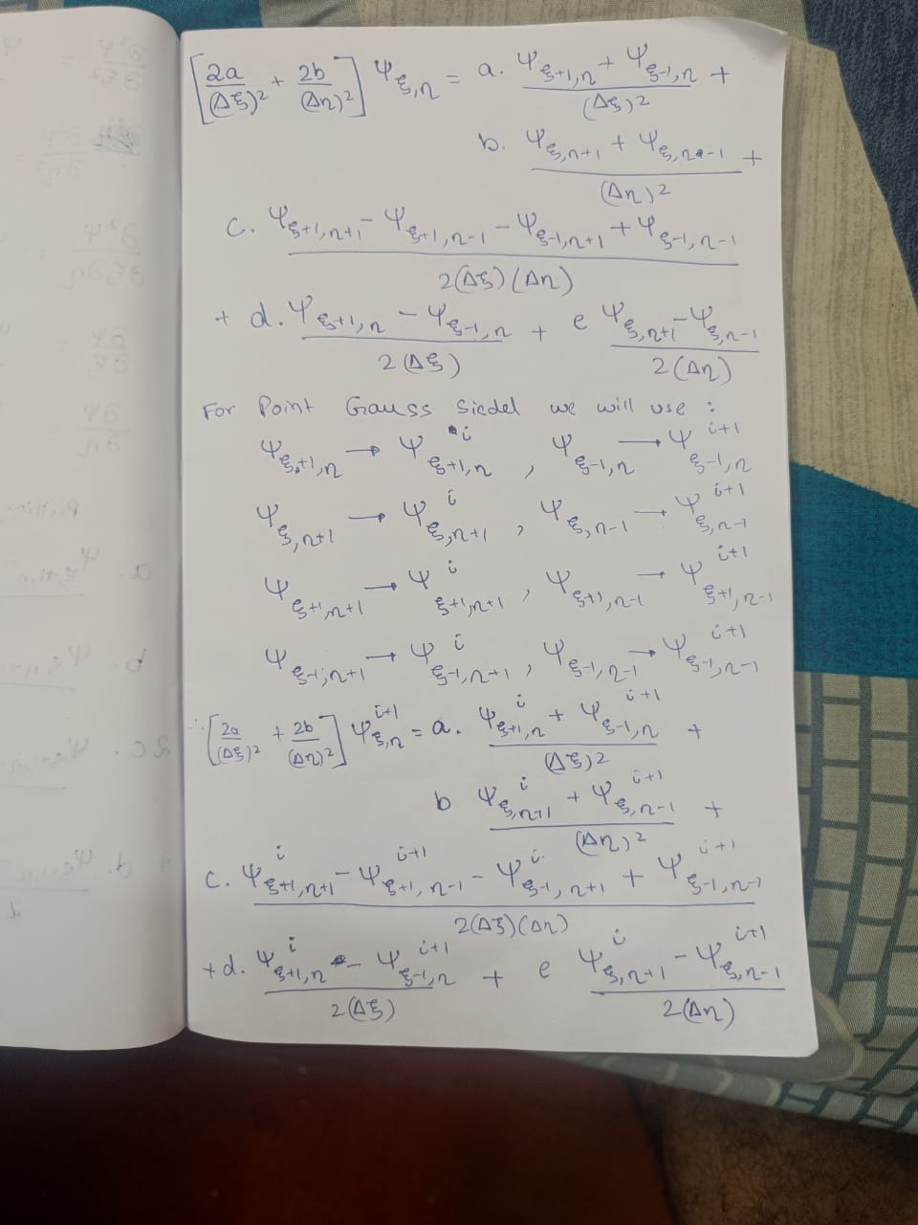

RESULTS:

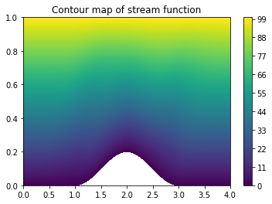

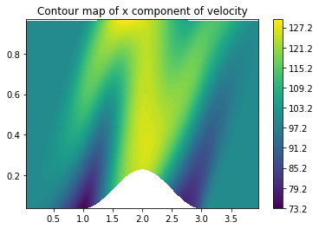

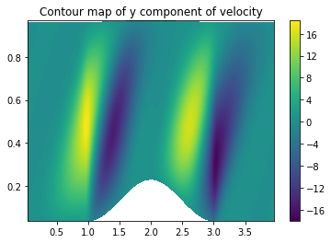

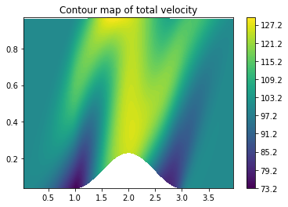

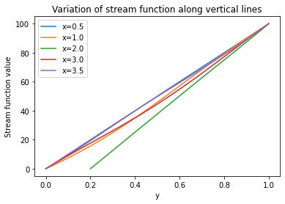

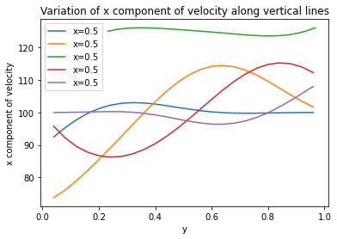

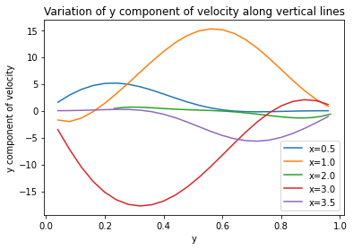

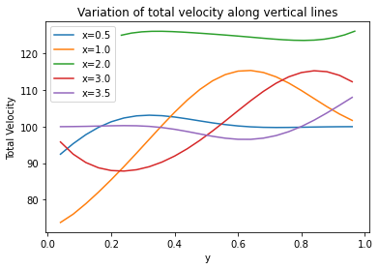

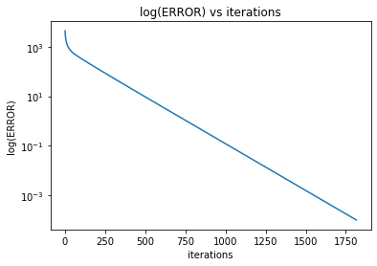

OBSERVATIONS:  
The Stream contour plot indicates a gradual increase in the stream function value from the base of the venturi to the top of the venturi.

The velocity values we can see that the velocity increases as the flow reaches on top of the bump and then decreases.

The Error plot also confines to the second order error.